**Gym & Fitness Website (Figma UI/UX Design)**  
**Tool Used:** Figma  
**Role:** UI/UX Designer  
**Design Type:** Desktop Web Design

**Project Overview**

This project focused on designing a clean, energetic, and user-friendly website for a fictional gym and fitness brand using Figma. The emphasis was on showcasing the gym’s services, branding, and user flow with clarity and motivation.

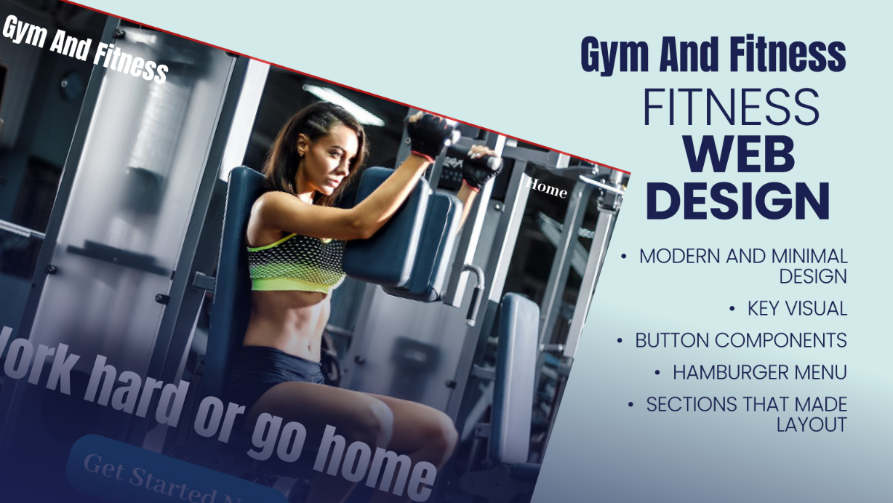

**Project Goals**

The goal was to create a compelling gym website that:

* Highlights the gym’s services and benefits
* Provides a seamless experience for new users
* Encourages actions like sign-ups, inquiries, and membership purchases

**Key Pages Designed**

**Home Page**

* Hero section with motivational tagline and “Get Started Now” CTA
* Intro to gym services, features, and testimonials
* “What You Get Here” preview section

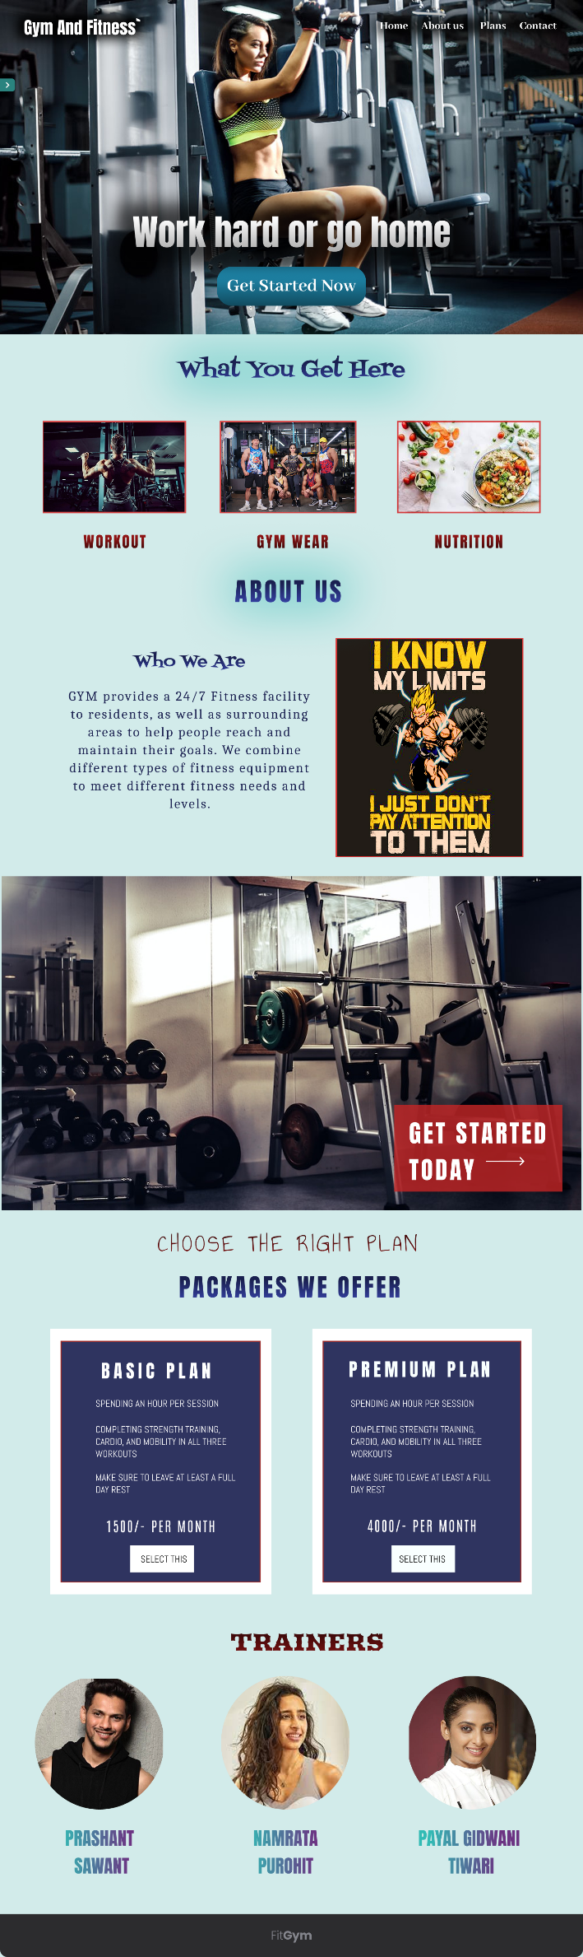

**About Us Page**

* Describes the gym’s mission, team, and values
* Builds credibility and trust with new visitors

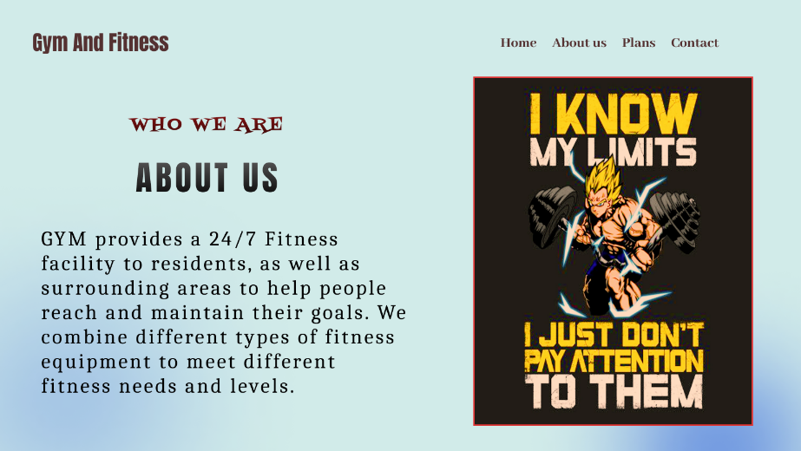

**Services Page (What You Get)**

* Card-based layout of gym facilities and offers
* Icons, titles, and short descriptions

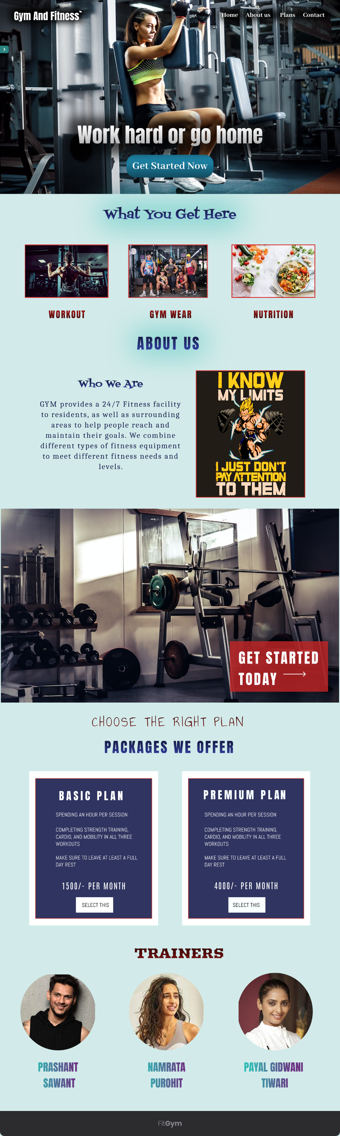

**Pricing Page**

* Clear pricing table layout
* Basic and Premium plans
* CTA buttons to sign up or get in touch

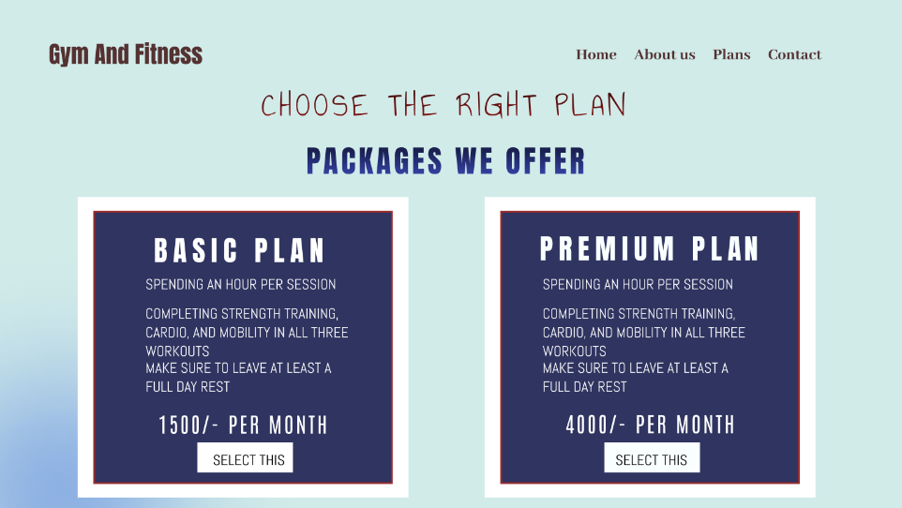

**Contact Us Page**

* Form with name, email, and message fields
* Map embed or location reference
* Footer with important links

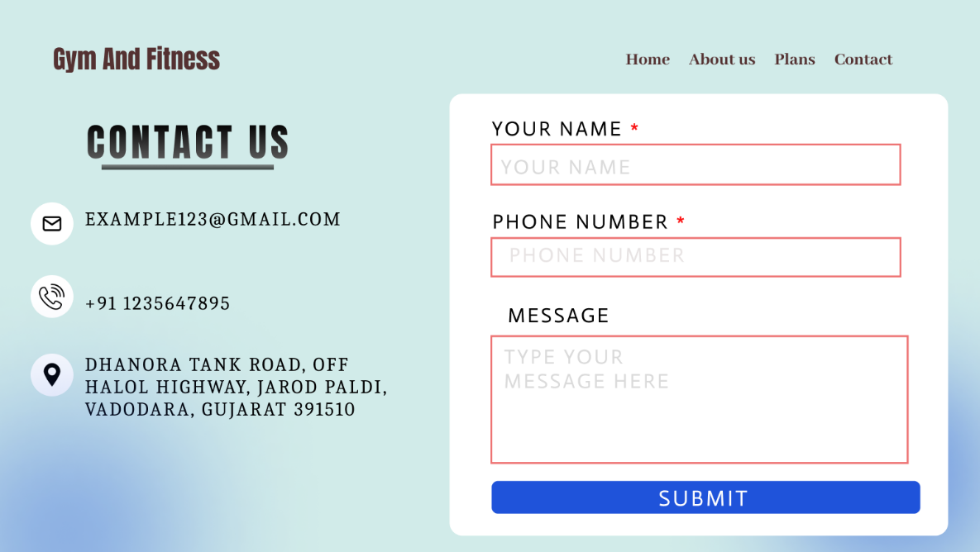

**Navigation (Hamburger Menu)**

* Responsive design elements included
* User-friendly mobile menu layout

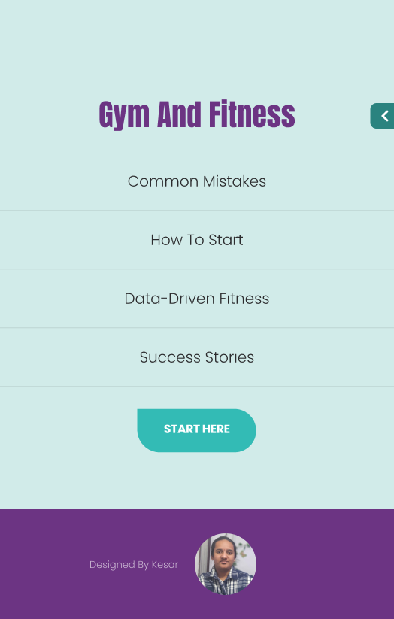

**Design Highlights**

* Consistent light color palette
* Strong typographic hierarchy for readability
* Grid layout for clean alignment
* Interactive CTA buttons for user engagement

**Outcomes & Learnings**

* Gained confidence in full UI layout creation
* Learned how to maintain branding consistency
* Improved user action flow and content clarity

**Project Summary Table**

| **Area** | **Detail** |
| --- | --- |
| Website Type | Gym & Fitness |
| Design Format | Desktop Web Design |
| Tool Used | Figma |
| Pages Designed | Home, About Us, Services, Pricing, Contact |
| Focus | Clarity, Energy, Motivation, Action |

**View Prototype Online**

👉 [Click here to view the interactive Figma prototype](https://www.figma.com/proto/z8KHWOssWHiPfxxjg0yt9k/Gym---Fitness-Website?node-id=2222-19&t=DdRbgtLrFrj8Mb1s-0&scaling=min-zoom&content-scaling=fixed&page-id=0%3A1&starting-point-node-id=2222%3A19)